**Title of the article:** *2022 starts with tax, price hikes on cigarettes, alcohol*

**Date the article was published:** *2nd January 2022*

**Date the commentary was written:** *26th May 2022*

**Word count of commentary:** *799 words*

**Unit of syllabus to which the article relates:** *Microeconomics*

**Key concept being used:** *Intervention*

**Article Link:** <https://business.inquirer.net/338025/cigarette-and-alcohol-tax-price-hikes-greet-2022>

Article

**2022 starts with tax, price hikes on cigarettes, alcohol**

MANILA, Philippines — The new year begins with another increase in “sin” taxes, meant not only to discourage smoking and drinking but also to raise more revenues to finance the universal health care (UHC) program being implemented by Philippine Health Insurance Corp. (PhilHealth).

Effective on Jan. 1, the excise on cigarettes is now P55 per pack, from P50 last year. The annual P5 increase in this tax until it reaches P60 per pack of cigarettes is in accordance with Republic Act No. 11346, or the Tobacco Tax Law of 2019.

And under Republic Act No. 11467, which amends the National Internal Revenue Code of 1997 when it comes to so-called sin products, the excise on conventional freebase or classic nicotine vaping products increases this year to P55 per 10 milliliters from P50 last year, while the tax on nicotine salt vapes is now P47 per ml, from P42 in 2021.

RA 11467 also jacked up the excise on distilled spirits — brandy, gin, rum, tequila, vodka, and whiskey — to P52 per proof liter from P47 in 2021, on top of the ad valorem tax of 22 percent of the net retail price.

Beer products including lager, ale, and porter have an excise of P39 per liter this year, up from P37 last year.

Meanwhile, the excise on wines has been increasing by 6 percent annually from the base of P50 per liter in 2020 when RA 11467 was enacted into law.

**Collections**

Despite the pandemic and its resulting lockdowns, which limited sales and distribution of sin products especially in 2020, sin tax collections from cigarettes and alcoholic beverages rose to a total of P227.6 billion from P224.6 billion in 2019 — exceeding the conservative P201.5-billion target.

The government has also been targeting increases in sin tax collection even amid reports of a thriving illicit cigarette trade, including smuggling in at least four ports flagged by lawmakers as “hot spots,” as well as the manufacturing of unregistered products in some economic zones.

The latest estimates of PMFTC Inc., the country’s affiliate of Philip Morris International, show that the sale of smuggled or fake cigarettes grew to 8.6 percent of the market last year compared with about 5.5 percent in 2020.

According to the Bureau of Internal Revenue, the 2.5 million illicit cigarette packs seized in 2021 amounted to some P123.3 million in lost tax revenues.

The Bureau of Customs, for its part, reported that year apprehending about 100 illicit cigarette traders and confiscating 38,827 master cases or P1.3 billion worth of illicit cigarettes. Foregone excise from these contraband was estimated at P970.6 million.

**Subsidy**

Amid those challenges, Finance Secretary Carlos Dominguez III vowed that the government would continue to finance the UHC program, which was enacted into law in 2019.

PhilHealth has actually been receiving the largest subsidy among all government-owned and/or -controlled corporations (GOCCs) since 2014.

The record-high 2022 national budget of P5.02 trillion allotted P80 billion to PhilHealth to cover premium subsidies for indirect contributors—including 13.2 million poor households and 7.3 million senior citizens.

The latest data from the Bureau of the Treasury also show that the government extended about the same amount, P76.9 billion, to that GOCC as of last November—or nearly half of the P163.4 billion allocated to other state corporations during that 11-month period.

On the other hand, PhilHealth has been criticized for failing to settle COVID-19 claims by private hospitals and for alleged corruption and mismanaged funds.

Furthermore, health costs and economic losses due to the consumption of sin products remained considerable despite the increase in sin tax collection, according to a recent report by Washington-based think tank Center for Global Development.

The Department of Finance said it was working on a “playbook” of strategies, including possibly new or higher taxes, which may be implemented by mid-2022 when a new administration takes over.

**Commentary**

The given article is about the government of Philippines increasing excise tax (**intervention**) on demerit goods such as cigarettes and alcohol. This is done to reduce the effect of the negative consumption externality that arises from the consumption of these goods. The goods mentioned above are demerit goods because they are overproduced by the market though they are undesirable for consumers. They also have external costs in the form of a less productive economy when they are consumed, thus have a negative consumption externality. The above-mentioned goods are examples of market failure.

**Negative externality of consumption arising from cigarettes (demerit goods)**

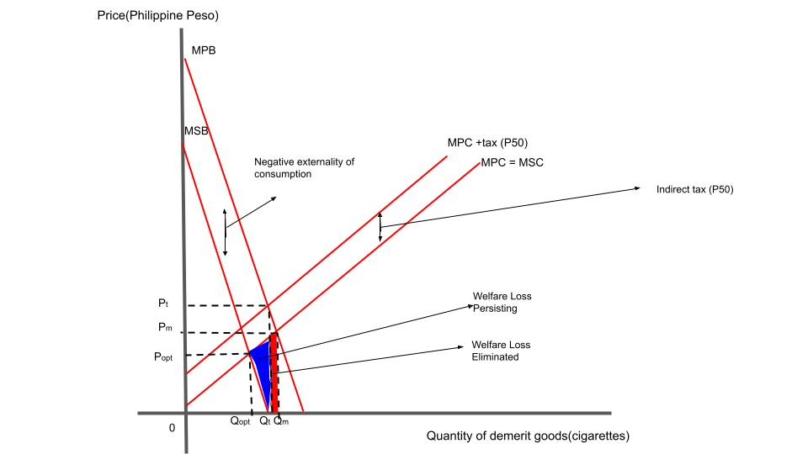

In Philippines the private benefit from consumption of demerit goods is greater than the society’s benefit(Shown by MPB > MSB). This is because when a person consumes a demerit good, there are losses to society in the form of a less productive economy. This is shown by the negative externality of consumption equal to the vertical distance between the MPB and MSB curves of the diagram. In the diagram, we see that initially the demerit goods are produced at quantity Qt and price Pt. This is determined by the intersection of MPB and MPC+tax(P50). The initial tax results in some welfare loss being eliminated that arises from no **intervention** (Shown by intersection of MPB and MPC), but the social optimal quantity is at Qopt and price Popt, determined by the intersection of MSB and MSC. This shows market failure in Philippines due to welfare loss.

To reduce the externality, the Philippines government increased the excise tax on demerit goods.

**Excise tax increase on cigarettes (demerit goods)**

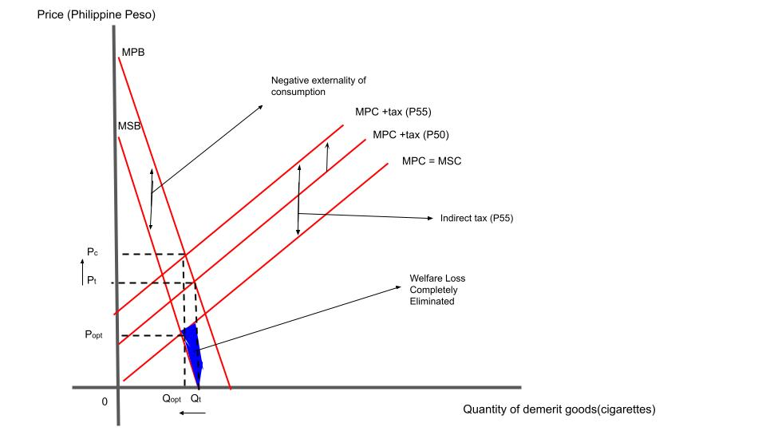

Increasing the excise tax, shifts MPC+tax(P50) further upto MPC+tax(P55). This is because there is an increase in costs of production reducing supply. Ideally, MPC+tax(P55) would intersect MPB at the socially optimal quantity Qopt. For this to happen, the excise tax has to be equal to the negative consumption externality. By doing this welfare loss is eliminated, and market failure is corrected through **intervention**. Though economic theory indicates that the externality is completely eliminated, this may not happen in Philippines due to the black market. Some people avoid the tax, hence there may still be some welfare loss.

The **intervention** affects both consumers and producers. Consumers now pay a higher price for demerit goods (Pc) and producers receive a lesser amount of revenue per good (Popt). The excise tax received by the government is equal to (Pc - Popt) * Qopt. Additionally total revenue decreases from Popt * Qt to Popt * Qopt.

We know that the government has **intervened** with the market for two reasons, to finance UHC and reduce consumption of demerit goods, are both goals achieved?

The government's goal to reduce consumption of demerit goods in the short run may not be achieved, which is a disadvantage of the **intervention**. Demerit goods tend to have an inelastic demand in the short run. This means though the price increases, consumers will still consume large amounts of demerit goods, but in the long run, their goal to reduce consumption of demerit goods may be achieved. This is because when a good has inelastic demand, the excise tax incidence on consumers is greater than the tax incidence on producers. This means consumers pay a larger sum of money to pay for the tax. Additionally, consumers in the long run have time to think about alternatives as demand becomes more elastic in the long run. Hence quantity demanded may reduce more than indicated by economic theory in the long run.

There are disadvantages associated with an increase in excise tax. In this case, the tax is imposed per unit of good for a fixed amount, so the taxes are regressive. This means that poorer consumers will be affected more than well-off consumers. This can increase income inequality. The **intervention** may reduce standards of well-being among consumers as they have lesser disposable income after consuming demerit goods. The **intervention** reduces producer revenue, and this can lead to the government facing opposition from producers. There may be higher unemployment rates.

There are also advantages associated with the increase in excise tax. This is in being able to finance UHC. In the long run, **intervention** on demerit goods means large revenues for the government since demerit goods tend to have an inelastic demand. This means even if an excise tax is imposed, demand reduces very slightly, and hence more consumers pay the tax. In the long run the government can accumulate large revenues from the excise tax. This can be used to finance UHC and other sectors.

The disadvantages associated with the increase in excise tax can be corrected by using regulations and advertising to control black-market activity. By using regulations and advertising along with tax, there is a higher probability to entirely reduce the negative consumption externality, reduce demand for demerit goods in the short run and reduce black market activity.